Blockchain on cloud

workshop guide

Table of Contents

Section 1 - Building a Development Environment 3

1.1 Install Prerequisites for Hyperledger fabric and composer 3

1.2 Install visual studio code 6

1.3 Install Hyperledger Composer tool set 7

# Section 1 - Building a Development Environment

## 1.1 install Prerequisites for Hyperledger fabric and composer

In this section, you will be installing required prerequisite for Hyperledger Fabric v1.2 and Hyperledger composer/playground.

* + 1. Click on the “Activities” located at the top left hand corner.

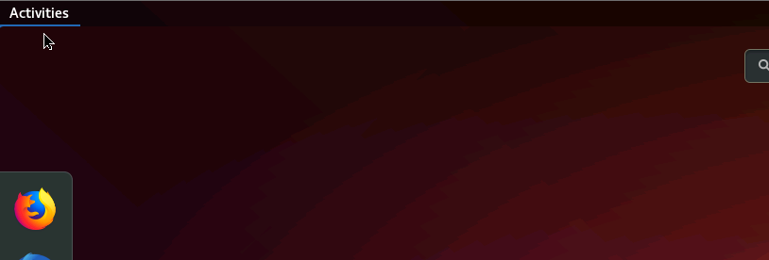

Pic 1.1.1 – Activities menu

* + 1. Type-in “terminal” and you will see two applications as shown below. Please click on “Terminal”

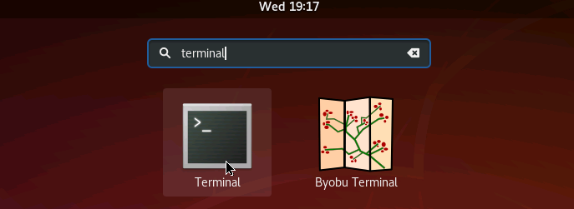

Pic 1.1.2 – Opening Terminal

* + 1. When you open the terminal app, please type the following command and that should

display list of folders and files located at the home folder.

ls -l

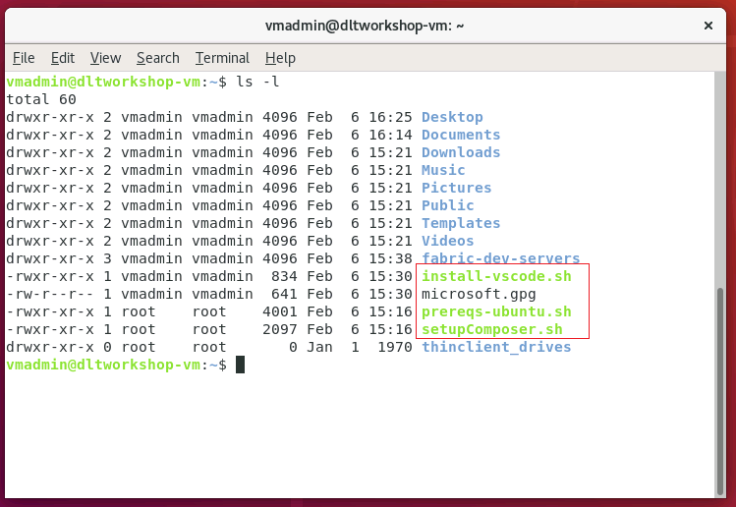

Pic 1.1.3 – Terminal window that list all the prerequisite install scripts

* + 1. We will be using “prereqs-ubuntu.sh” script to install the following dependencies need for Hyperledger Fabric and Composer tool set.
* Git
* npm
* NodeJS
* Docker-ce
* Docker-Compose
* Python
* Unzip

Please run the following command and execute “prereqs-ubuntu.sh” script.

./prereqs-ubuntu.sh

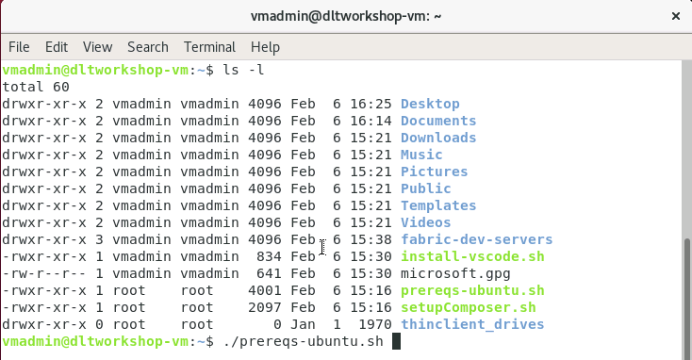

Pic 1.1.4 – Terminal window with command to run ./prereqs-ubuntu.sh script

Please let the script: prereqs-ubuntu.sh run and wait for the following message: “Please logout then login before continuing“

When you see this message you can execute the following command or manually reboot your VM.

sudo reboot now

## INstall visual studio code

Here we will using a script to install Visual studio Code editor. You can find more information about this edit at <https://code.visualstudio.com/>

Please run the following command and execute “install-vscode.sh” script.

./install-vscode.sh

Once the installation complete, please launch the code editor. You can just type “code” from the terminal window to open the app.

code

Once the app running, please click on Extensions button at the top left hand corner.

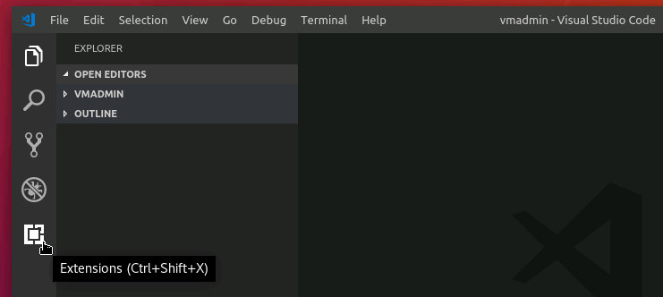

Picture 1.2.1 – Code editor

Please type “Hyperledger” on market place search box. You should see Hyperledger composer as one of the result. click on “install” to install the composer extension.

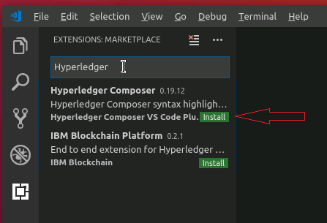

## 1.3 Install Hyperledger Composer tool set

Now that we have all the prerequisite installed, let’s install Composer tool sets and Fabric.

Please run setupComposer.sh script found under the home directory.

./setupComposer.sh

This script install the following components:

* Composer-cli – command line interface to Composer
* Composer-rest-server - Utility for running a REST Server on your machine to expose your business networks as RESTful APIs.
* Generator-hyperledger-composer - Useful utility for generating application assets.
* Yo - Yeoman is a tool for generating applications, which utilises generator-hyperledger-composer
* Composer-playground – web application that enables testing of Blockchain models.
* Deploy Fabric framework and starts a sample single organization based network.
* Creates a Peer admin card
* Finally, runs composer-playground web application.